**Use template in smart forms**

For the initial steps to create a smart form, please refer the previous demos.

1. Create a smart form.

2) Double click on Form Interface and declare the following two parameters

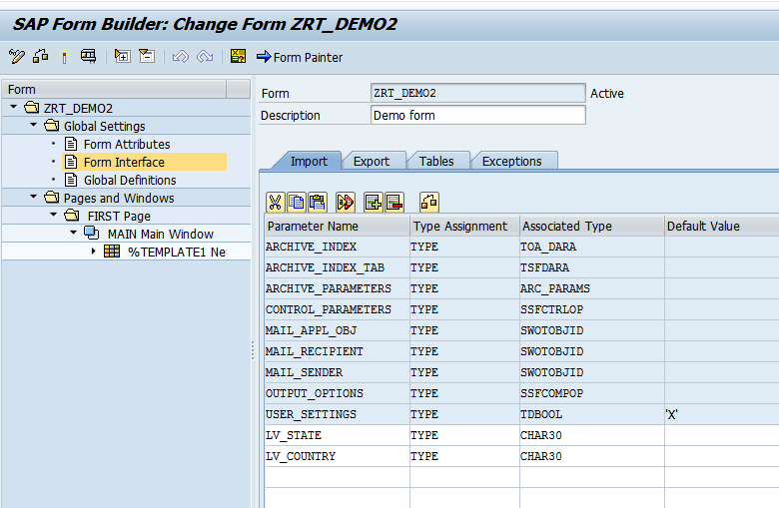

3) Right click on Main window.  
 Create-Template

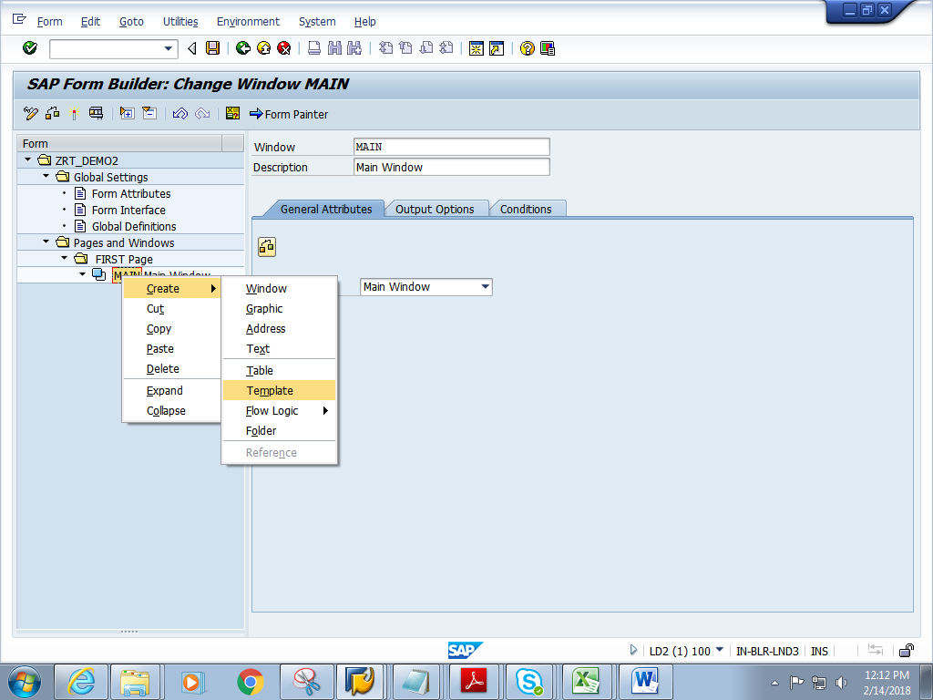

4) Double click on Template. Click on Pattern button .Choose a suitable pattern. Click enter.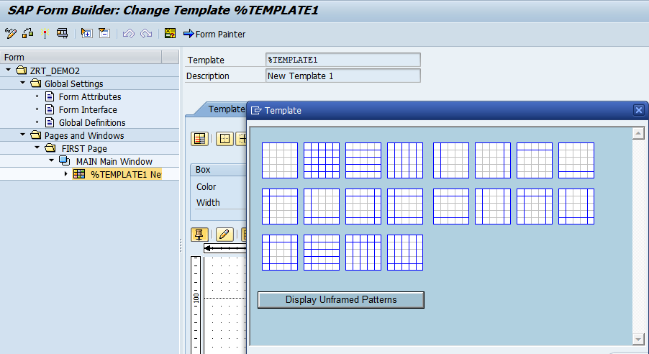

5) Click on details button

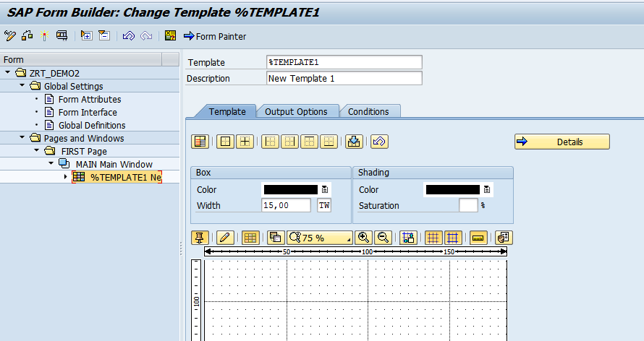

6) Give the Template width. Add C1 and C2 with the following values

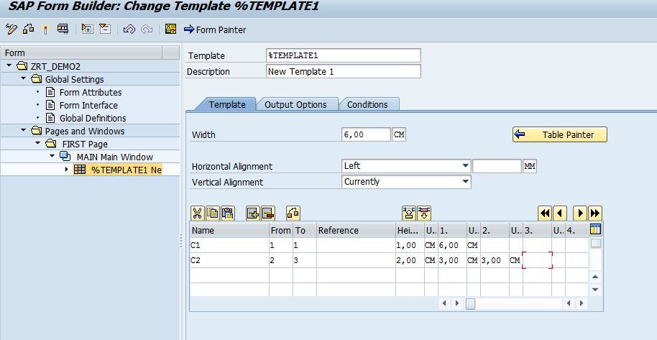

7) Right click on TEMPLATE. Create->TEXT.  
 Create 5 such texts under TEMPLATE.

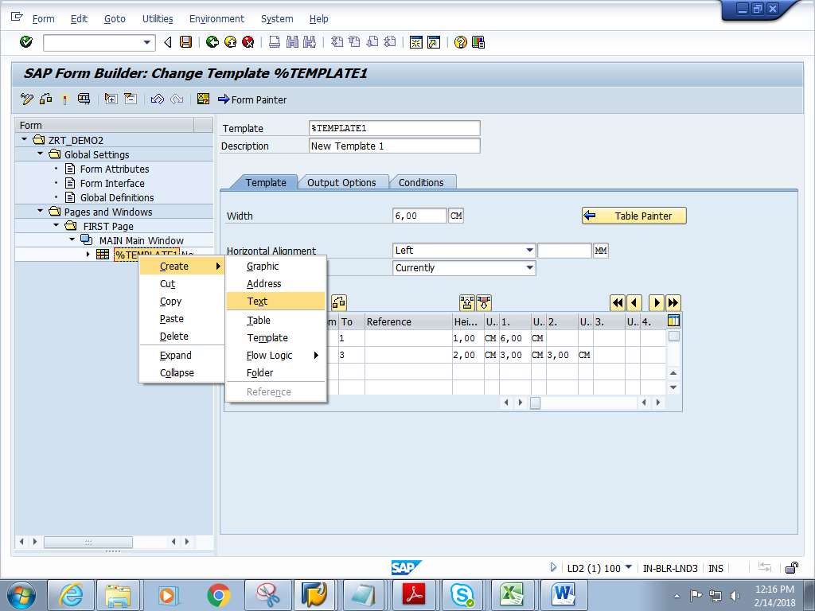

8) Double click on TEXT1.Add the following text. Click on Output Options

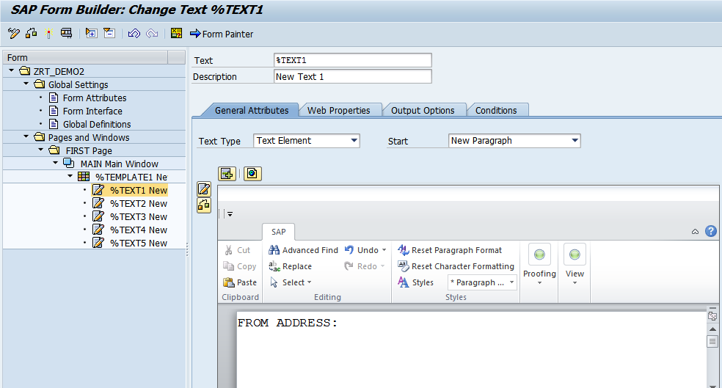

9) Give the LINE and Column values as 1 each.

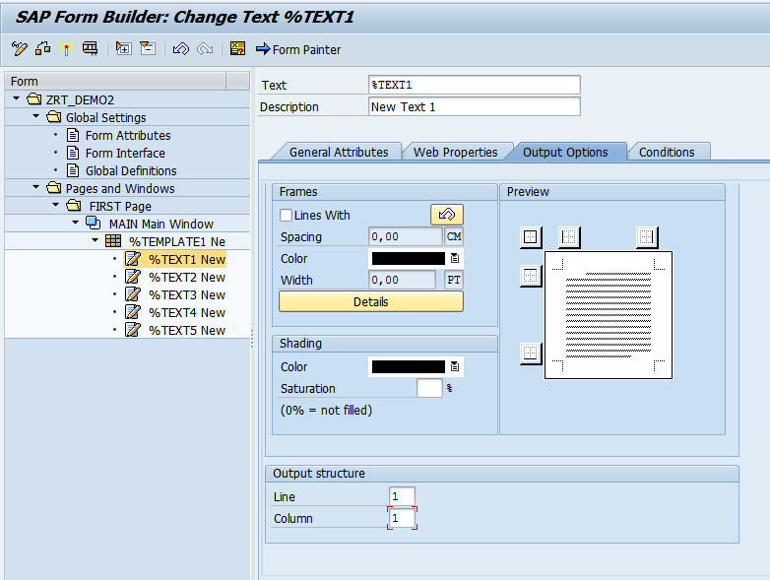

10) For TEXT2.   
In General attributes tab, give the text   
In output Options tab, give the Column and Line values

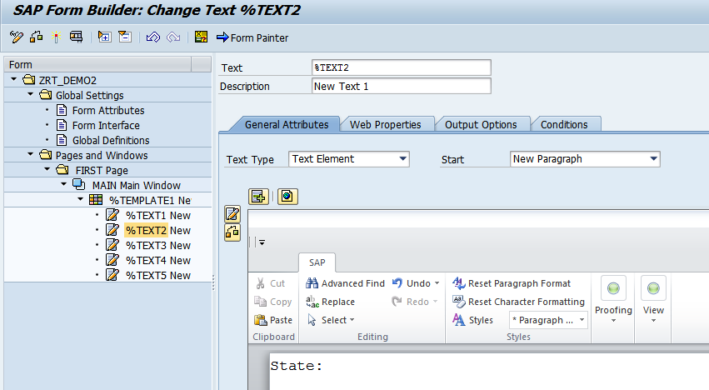

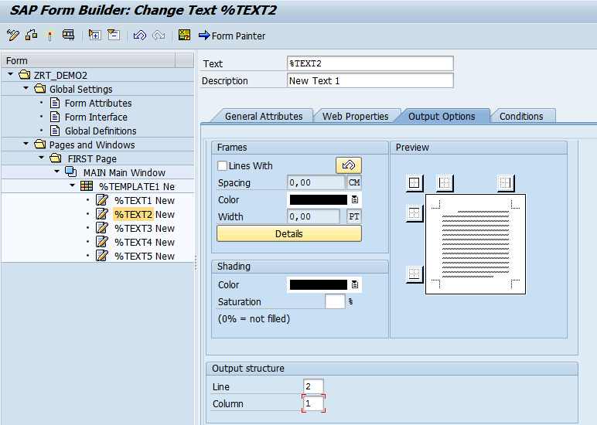

11) For TEXT3

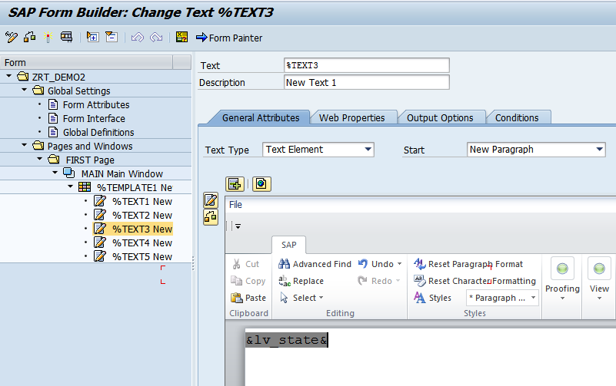

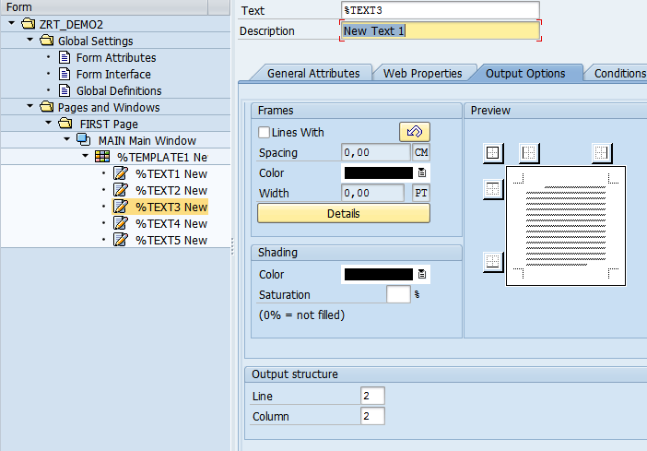

12) For TEXT4

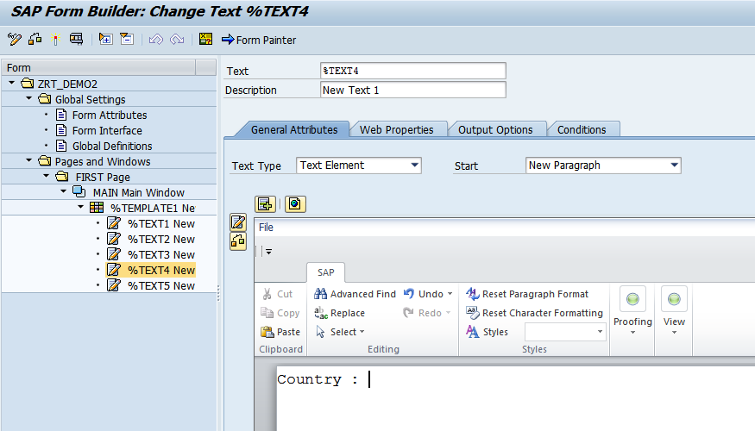

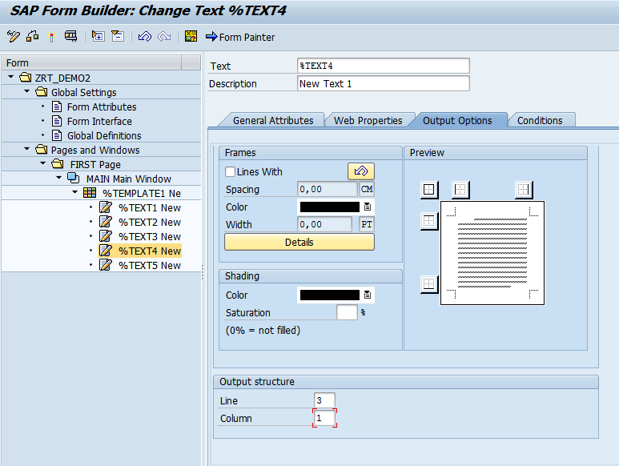

13) For TEXT5

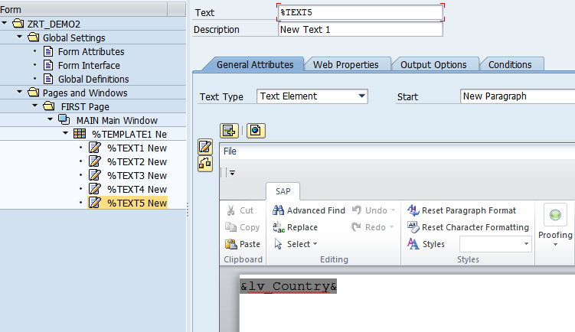

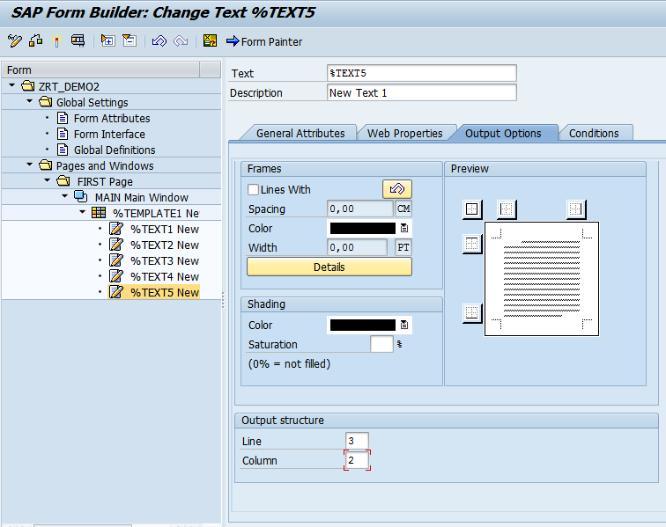

14) Save and activate the form.

15) Execute the form .Execute the function module. **Give the State and Country.**.

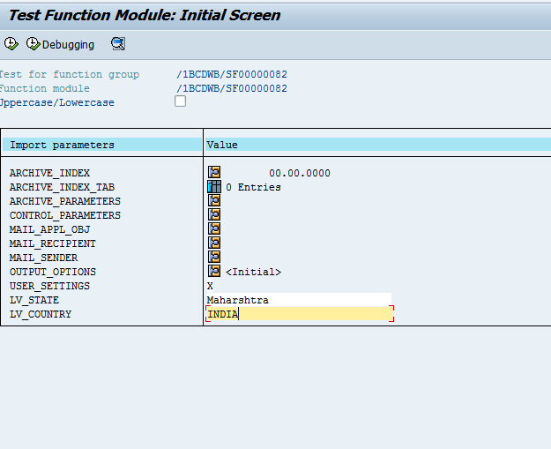

21) Click on Print preview

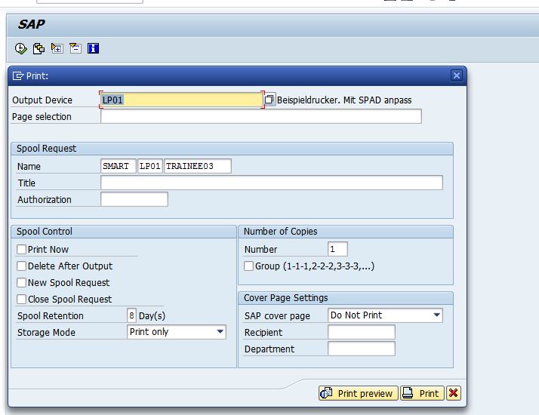

22) Expected output is as follows.

